OCU Music History Diagnostic Examination for Incoming Graduate Students

The Music History Diagnostic Examination is designed to evaluate incoming students' familiarity with general topics in Western music history from Antiquity to ca. 1950. The recommended media for study are:
1.) Burkholder, Peter, Donald J. Grout, and Claude V. Palisca. A History of Western Music, 9th edition (Norton, 2014)
2.) Norton Anthology of Western Music, 7th edition (Norton, 2014) (score anthology and audio CDs)
3.) Davison, Archibald T. and Willi Apel. Historical Anthology of Music. Vols. 1 & 2 (Harvard, 1950, rev. 1977)

The exam will be divided into four sections:

1. Multiple choice (12 items): 12 multiple-choice questions covering a range of music history topics.

2. Terminology ID (12 items): Define in two or three sentences 12 self-selected terms and concepts from a large list of general music history items. See the study guide for a list of potential terms.

3. Listening ID (3 examples, 6 items): Identify the genre, date, and composer of three listening examples, and qualify the responses with a brief stylistic analysis (harmonic & melodic language, form, compositional technique, cadences, texture, etc. where applicable).

4. Score ID (3 examples, 6 items): Identify the genre, date, and composer of three unknown score examples, and qualify the responses with a brief stylistic analysis (harmonic & melodic language, form, compositional technique, cadences, texture, etc. where applicable).

Students are evaluated according to their performance in items related to two chronological periods: Antiquity to ca. 1730, and ca. 1730 to ca. 1950. Course deficiencies will be determined according to the exam results for these two chronological periods.

MUSIC HISTORY DIAGNOSTIC EXAM SAMPLE ITEMS AND TERMINOLOGY STUDY GUIDE

SECTION 1: MULTIPLE CHOICE
EXAMPLE. The "galant" style features:
a. thematic transformation and elongated phrases
b. modal counterpoint with occasional moments of homophony
c. atonality and irregular rhythms
d. regular, periodic phrasing and simple harmonic accompaniment

SECTION 2: TERMINOLOGY
Definitions should be concise (2-3 sentences) and accurate.
EXAMPLE. Cavatina: In opera, a character's first entrance aria. Commonly associated with 19th c. Italian opera, such as those by Rossini, Donizetti, Bellini, and Verdi.

In addition to being able to identify representative composers and works from all stylistic periods, you are expected to be familiar with the following terms and concepts (the terms listed here will in part comprise the "terminology" section of the exam.)

Tetrachord  Greater Perfect System  Gregorian chant  Mass Proper  Mass Ordinary  The Divine Office  Church modes  Solmization  Antiphon  Sequence  Troubador  Trobairitz  Minnesinger  Organum  Magnus liber organi  Motet  Rhythmic modes  Ars nova  Isorhythm  Ars subtelior  Trecento  Formes fixes  Squarcialupi codex  Hocket  Contenance angloise  Fauburden  Cantus firmus mass  Imitation mass  Paraphrase mass  Musica ficta  Dodekachordon  Chorale  Metrical psalm  Anthem  chanson  Council of Trent  Frottola  Madrigal (16th c.) | Concerto delle donne  Ricercare  Cori spezzati  Le nuove musiche  Basso continuo  Basso ostinato  Monody  Seconda prattica  Cantata  Oratorio  Sonata da camera  Sonata da chiesa  Concerto  Concerto grosso  Ritornello  Tragédie en musique  French ouverture  Suite  Style brisé  Agréments  Aria da capo  Opera seria  Zarzuela  Empfindsam  Galant  Opera buffa  Intermezzo  Symphony  Opéra comique  Sonata-Allegro Form  Rondo  Mannheim school  Sturm und Drang  Piano sonata  Heiligenstadt testament  Song cycle  Romanticism | Absolute music  Program music  Character piece  Ideé fixe  Bel canto  Cabaletta  Cavatina  Tempo di mezzo  Melodrama  Grand opera  Gesamtkunstwerk  Leitmotiv  Mighty Handful  Symphonic poem  Verismo  Minstrelsy  Blues  Ragtime  Jazz  Orchestral song  Operetta  Pentatonicism  Octatonicism  Expressionism  Atonality  2nd Viennese School  12-tone serialism  Sprechtstimme  Klangfarbenmelodie  Ballet Russes  Neoclassicism  Polytonality  Socialist realism  Les Six  Gebrauchsmusik  Darmstadt School  Musique concrète  Indeterminacy  Minimalism

SECTION 3 & 4: LISTENING & SCORE ID (Question format applies to both sections)
SCORE ID EXAMPLE.
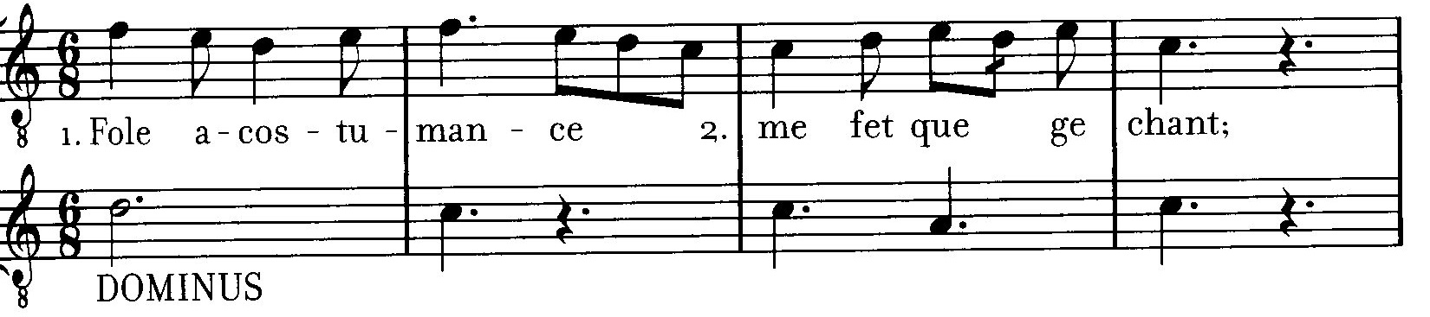

Date:
1st century B.C.E. c. 500 c. 1200 c. 1400 c. 1550 c. 1700

Composer:
Dufay Palestrina Bach Anonymous Landini Corelli

Genre:
Motet Opera Sequence Cantata Fugue

2. Qualify your responses with a stylistic analysis:
This is a two-voice polyphonic motet, with both voices singing different texts and melodic lines. The bottom voice sings a chant melody on "Dominus" in sustained tones while the top voice subdivides the rhythm of the bottom voice in rhythmic modes.

